Recording Food Receipts on the iPad
Step-by-Step Instructions
Each device is personalized to a specific partner agency – it is how the database knows which agency is submitting the receipt. You may not trade devices with another pantry.
Wake up the iPad by pressing the button located on the top right of the device.
Unlock the iPad by pressing the button located in the bottom middle of the device. Now the home screen of the iPad will display.
To record the receipts, we use an app called FileMaker Go. It is the turquois file icon located in the middle of the screen.

Touch the icon to open the app.
If this screen appears, press the folder that says “OFS Donorware.”

**If this screen does not appear, move on to the next steps.
Now you’ll see the main menu of the app.

To start a receipt, touch the white “+” sign that is to the right of the store whose receipt you want to record.
On the Collection Screen, you will see the name of your agency, donation date, and your agency ID number, the grocery store or restaurant name and number.

Touch the “+” in the “Add Item” box.

Now, touch the drop-down arrow and touch the department that best represents the type of food donated.
Touch the Quantity space.
Then enter the quantity. Press Done. | 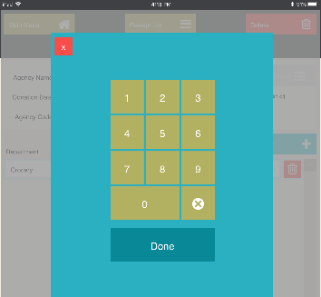
Then select the unit by tapping the down arrow on the unit. Then touch the unit you use to track your items. | 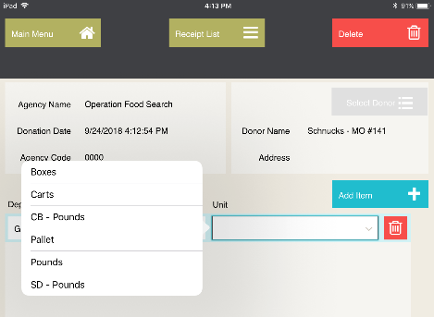
You will add an item for each department category you picked up that day. | 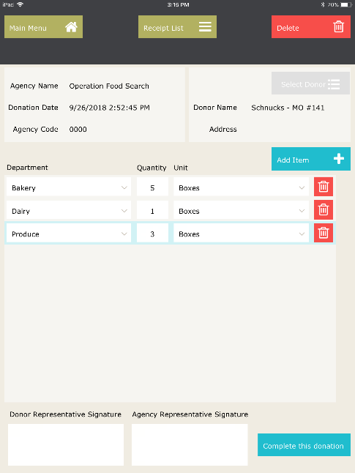
At any point, if you make a mistake on one of the items, touch the red trash can icon in order to delete that item only.

If you need to delete the entire receipt, touch the red Delete button located on the upper right side of the screen.

After all the goods have been recorded, you will need to obtain the Donor Representative and the Agency Representative’s signatures.

Do this by clicking the white box below the appropriate signature line.
A white screen will appear where the representative may sign using their finger. After signing, press the Accept button on the top right corner of the screen.

Complete the same process for the other signature.

**Both signatures must be obtained for every receipt.

Now that the receipt is complete, you will tap the Mark Complete button in the lower right corner.  Once you tap this button, however, you will no longer be able to delete or make any changes to the receipt. If you realize there was a mistake on the receipt, please contact someone on the OFS Partner Relations Team as soon as possible. | 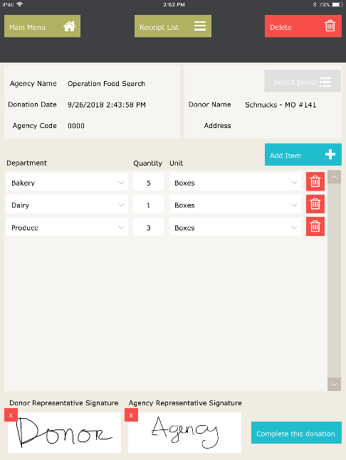
The next screen will show your “queue” of completed receipts.

At this point, you will either return to the main menu by touching the green “Main Menu” box or upload the receipts by touching the blue “Upload Receipts.”

The receipts can only be uploaded when the iPad has a strong Wi-Fi connection. If you need to wait to upload all the receipts from that day until you have returned to your pantry and have a Wi-Fi connection, please do so.

The iPad will store the completed receipts for you.
If you need to wait to upload the receipt but need to capture additional receipts, touch the green “Menu” box and it will go back to the list of stores and you can start a new receipt.  When you have a strong Wi-Fi connection, go to the green “Menu” box and from the drop down list touch “Upload Receipts.”  You will receive a screen that indicates the receipt(s) have been uploaded. Touch “OK.” | 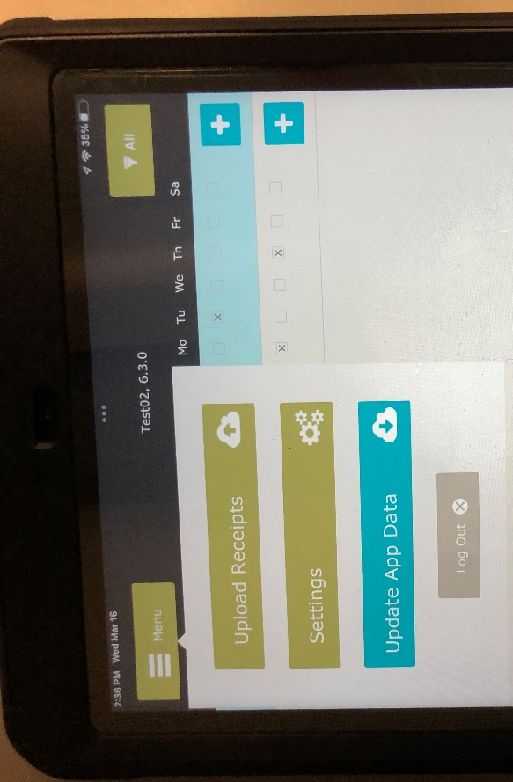
To put the device to sleep, press the button on the top of the device once.

Turning the Device On/Off  If you ever want to turn the device on/off, do so by holding down the button on the top of the iPad until a slider appears. Slide to turn the device on/off. | Press  &  Hold

For additional assistance or questions contact: Agency Relations Associate

