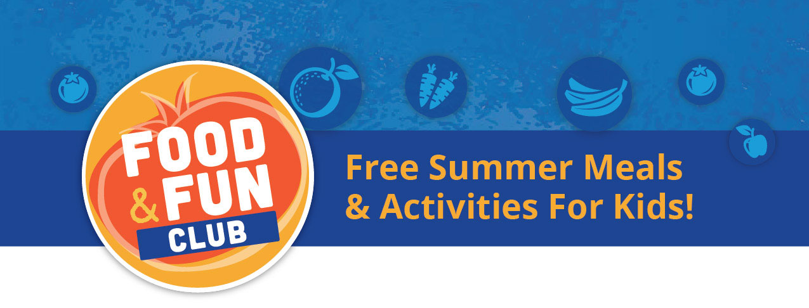

# Have more questions about the program?

# Contact OFS at 314-726-5355 x 124 or learn more at WeFeedKidsSTL.org.

# Where are the meals served?

# Text “FOOD” to 877-877 to find a location near you.

# What is the cost?

# It’s FREE for all children 18 and younger.

# What food is served?

# A nutritious meal that includes fruits, vegetables, grains, protein, and milk.

# What is the Food & Fun Club?

# Through the Food & Fun Club, Operation Food Search (OFS) is connecting thousands of kids to meals and fun activities at multiple locations during the summer. This program is funded by the U.S. Department of Agriculture (USDA).

(xxx)yyy-yyyy

* Organization